Build and edit the formula

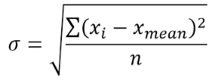

Text

$$σ=\sqrt{\frac{\sum{{(x_{i}-x_{mean})}^{2}}}{n}}$$

Text

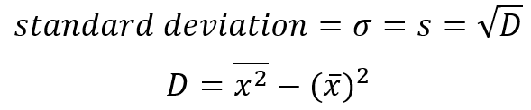

Text

$$D=\overline{x^{2}}-{\left(\overline{x}\right)}^{2}$$

$$D=\overline{x^{2}}-{(\overline{x})}^{2}$$